F. EXAMPLE PROJECTS WHICH BEST ILLUSTRATE PROPOSED TEAM’S QUALIFICATIONS FOR THIS CONTRACT  (Present as many projects as requested by the agency, or 10 projects, if not specified. Complete one Section F for each project.) |  |  |  |  |  |  | 20. EXAMPLE PROJECT KEY NUMBER  02
21. TITLE AND LOCATION (CITY AND STATE)  Orange County Transportation Authority (OCTA), I-5 Widening Segment 2 | Mission Viejo, CA |  |  |  | 22. YEAR COMPLETED
 |  |  |  | PROFESSIONAL SERVICES  Ongoing |  |  | CONSTRUCTION (IF APPLICABLE)
23. PROJECT OWNER’S INFORMATION
a. PROJECT OWNER  OCTA |  | b. POINT OF CONTACT NAME  Nial Barrett, PE |  |  | c. POINT OF CONTACT TELEPHONE NUMBER  (714) 560-5879
24. BRIEF DESCRIPTION OF PROJECT AND RELEVANCE TO THIS CONTRACT (INCLUDE SCOPE, SIZE AND COST)

- Caltrans D12 Project CM Experience
- JPCP Pavement
- HMA Pavement
- Freeway Widening
- Interchange Improvements
- Long Linear Corridor Traffic Management
- Caltrans Specifications
- Multiple Stage Construction
- Extensive Local Cities Coordination
- Railroad Coordination
- SWPPP / Environmental Compliance
- Retaining and MSE Walls
- Materials Testing Coordination
Project Relevance
S2 is currently providing materials testing services for this project between Oso Parkway to Alicia Parkway, located within the City of Mission Viejo.
Role/Scope of Services Provided The project adds one northbound (NB) and one southbound (SB) general purpose lane on I-5 between Alicia Parkway and Oso Parkway, reconstructs the La Paz Road Interchange, reestablishes existing NB auxiliary lanes, constructs new auxiliary lanes, and improves several existing on- and off-ramps. The entire La Paz Road undercrossing bridge will be constructed in three stages, ultimately moving the existing freeway centerline approximately 85-feet to the east through the project during construction. Overall, the project consists of construction of 22 walls as well as soundwalls, roadway widening, freeway widening, new barrier rail and soundwalls, coordination with local utilities, Metrolink, and Caltrans. S2 is providing staff augmentation to Caltrans for materials testing. Detailed work includes foundation piles (pile shafts in wet conditions), retaining walls, sound walls, bridge construction through deck and joint seal construction, highway paving, striping, signs, signalized intersections, coordination with permitting agencies, Caltrans, City of Mission Viejo, local water district and Metrolink.

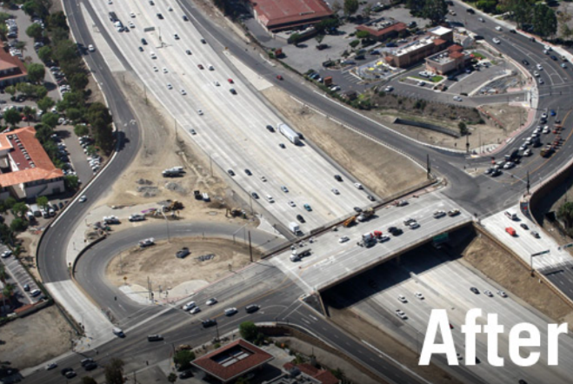
Project Successes. Our highly qualified professionals support Caltrans as they administer the construction contracts and monitor the quality of the contractor’s work. We are assisting the Caltrans resident engineer and the OCTA project manager with managing the project’s budget and are all working diligently to ensure the project is delivered on time and on budget.
25. FIRMS FROM SECTION C INVOLVED WITH THIS PROJECT
a. | (1) FIRM NAME  S2 Engineering, Inc |  | (2) FIRM LOCATION (CITY AND STATE)  Laguna Hills, CA |  |  | (3) ROLE  Subconsultant: Quality Inspection / Material Testing
STANDARD FORM 330 (REV. 7/2021) PAGE 3

